Software Engineering

**Wandering in the Woods Game**

Student Name

Siva Parimisetty

Santhosh Reddy Thatikonda

# 

Table of Contents

Introduction 2

Project Overview 2

Use cases : 3

User journey map 5

Result and output 6

Output 10

Conclusion 18

Reference: 20

# Introduction

In the process of creating "Wandering in the Woods," the software architecture, tool requirements, and design are meticulously defined. This report serves as documentation for both developers and users, providing a clear roadmap for future improvements and iterations. The attached paperwork and framework ensure the game's sustainability and scalability. This game implementation is an innovative educational game designed to foster both fun and mental growth among school students. This report offers a comprehensive insight into the game's development and objectives, serving as a blueprint for users and developers alike. The primary goal of "Wandering in the Woods" is to provide an immersive learning experience through an engaging forest adventure. As students navigate the challenges of the game, they not only enhance their problem-solving skills but also build self-confidence. With its structured division into three grade categories, the game caters to a wide range of abilities and encourages cognitive development in an enjoyable and interactive manner.

# Project Overview

The "Wandering in the Woods" project is a multifaceted educational endeavour aimed at enhancing students' mental growth. Divided into three distinct grade categories, the game is strategically designed to accommodate the unique developmental needs of students from K-2, grades 3-5, and grades 6-8. In grades K-2, the game introduces young students to problem-solving and exploration through square grids and joyful encounters. Grades 3-5 provide a more customizable experience with rectangular grids and increased player options, while grades 6-8 offer a challenging environment for experimentation and research. The game's development involves meticulous documentation, including software architecture and tool requirements, to ensure its longevity and scalability. This report serves as a vital resource for both developers and users, promoting collaboration and innovation. "Wandering in the Woods" is more than just a game; it's a tool for education and personal growth, and this project aims to shape the future of learning.

# Use cases :

* Use Case 1:

In Use Case 1, the game starts with the student as the actor. The student installs the game as it's new. They open the game, click on the homepage, and then select the "start" option on the screen.

* Use Case 2:

In Use Case 2, the student plays the game and navigates the grid. They select the game from the menu, start it, and click the "play" option on the screen. Grid lines are displayed, and the student begins playing.

* Use Case 3:

Use Case 3 involves the student choosing their grade level. The student selects a stage, starts the game, and then chooses a grade. They click the "play" option, and the grid lines are displayed.

* Use Case 4:

In Use Case 4, the student views statistics during gameplay. They select a screen, start the game, choose a grade, and click "play." The game displays statistics on the screen as the student plays.

* Use Case 5:

Use Case 5 involves the student replaying the game multiple times. The student selects a screen, starts the game, chooses a grade, and clicks "play." After playing, the student selects the "replay" option.

* Use Case 6:

In Use Case 6, the student exits the game. They start the game, exit, and then play the game again before exiting the game and closing the window.

* Use Case 7:

Use Case 7 to describe students in grades K-2 starting the game. They begin the game, and when two students share a screen, a happy emoji is displayed. The game restarts, and statistics about the number of moves are provided on the screen.

* Use Case 8:

Use Case 8 involves students in grades K3-5 or K6-8 altering the size of the grid. They start the game, change the grid size, and meet with other students to trigger a happy emoji display. Statistics about the number of moves are provided based on student input.

* Use Case 9:

In Use Case 9, students in grades K3-5 or K6-8 modify the grid size. They start the game, change the grid size, and meet with other students, leading to a happy emoji display. Statistics are calculated based on student movements.

* Use Case 10:

Use Case 10 introduces new challenges in the game for students in the K6-8 group. They start the game, change the grid size, meet with others, and the game calculates the number of movements for each student.

* Use Case 11:

In Use Case 11, students in the K6-8 group experimented with different methods in the game. They start the game, change the grid size, meet with others, and the game tracks the number of movements based on student input.

These use cases outline the various interactions and actions of students within the "Wandering in the Woods" game. The game caters to different grade levels, offering a dynamic and educational experience. Students can start, play, alter grid sizes, and explore different strategies while the game provides feedback and calculates statistics. These use cases collectively illustrate the diverse functionality and engagement opportunities the game offers to students of varying age groups.

# User journey map

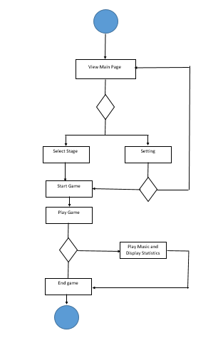

**Figure 1: User Journey map**

In this user journey map it is illustrated that the seamless interaction between the work put in and the user's requirements. A skilled businessman can intuitively discern user needs, forming a crucial bond between users and developers. This understanding is vital for enhancing the product as user feedback guides improvements. It's a symbiotic relationship where developers grasp user requirements effortlessly, aligning them with creative ideas to showcase their expertise. The collaborative synergy between user insights and developer skills ensures the product evolves to meet and exceed user expectations. This intricate dance of perception and innovation fuels continuous enhancement and user satisfaction.

# Result and output

The "Wandering in the Woods" game has successfully provided an engaging and educational experience for students across different grade levels. Through a series of carefully defined use cases, students can install, start, and play the game, adjusting grid sizes and exploring various strategies. The game's ability to offer statistics, feedback, and replay options enhances the learning process. As a result, students have the opportunity to develop problem-solving skills, gain confidence, and enjoy a unique blend of entertainment and personal growth. "Wandering in the Woods" has effectively met its objectives by accommodating diverse user actions and catering to the specific needs of each grade level.

After analyzing the data we have found,

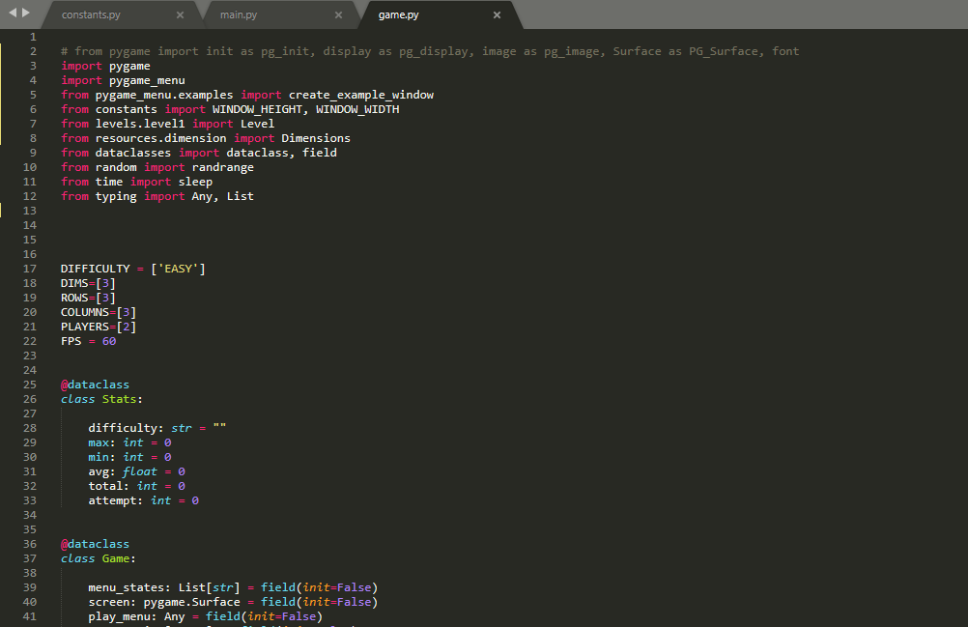

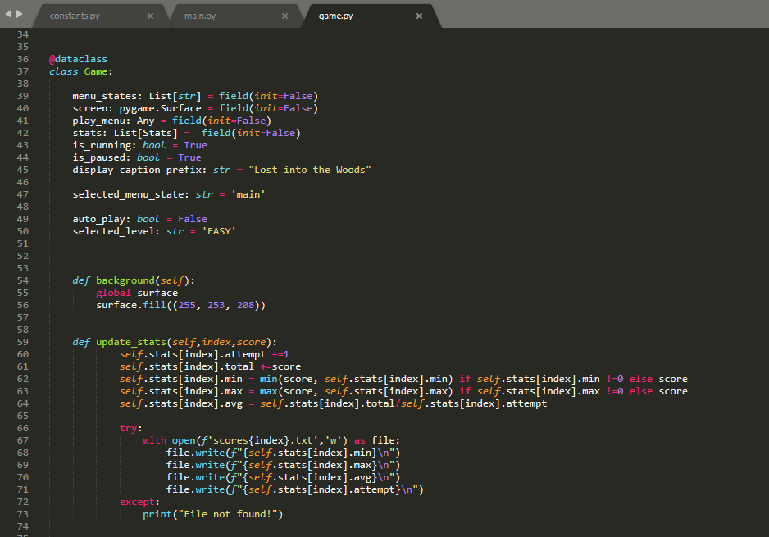

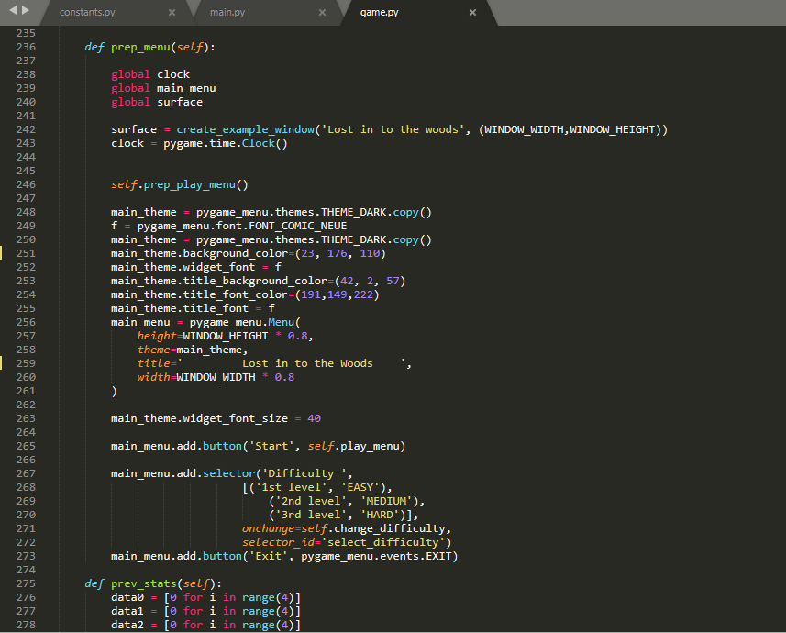

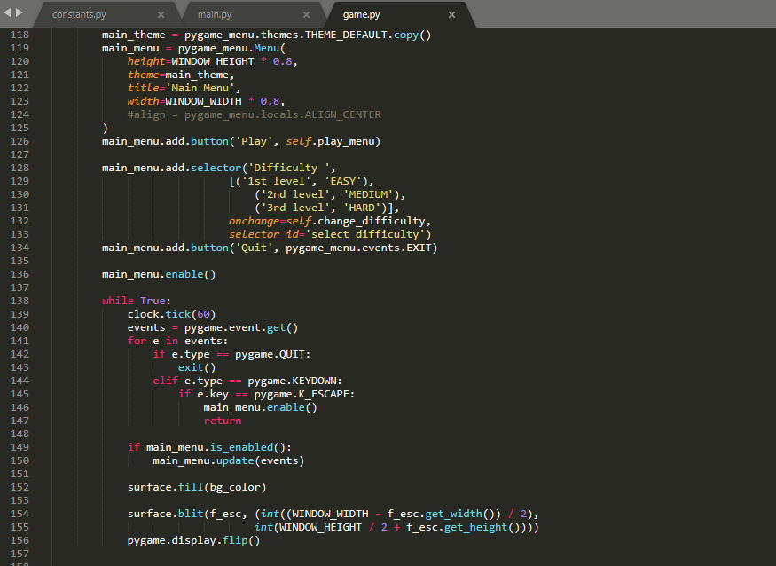

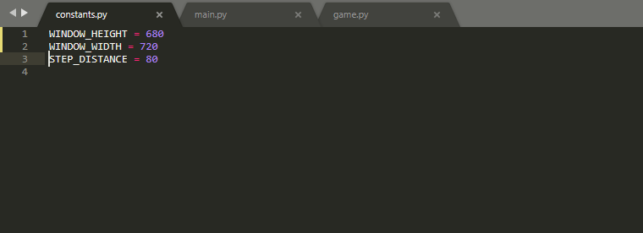

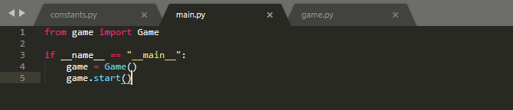

# Output

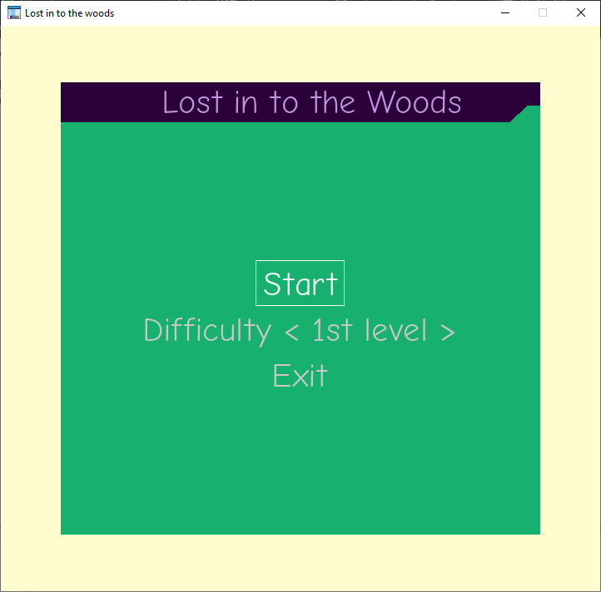

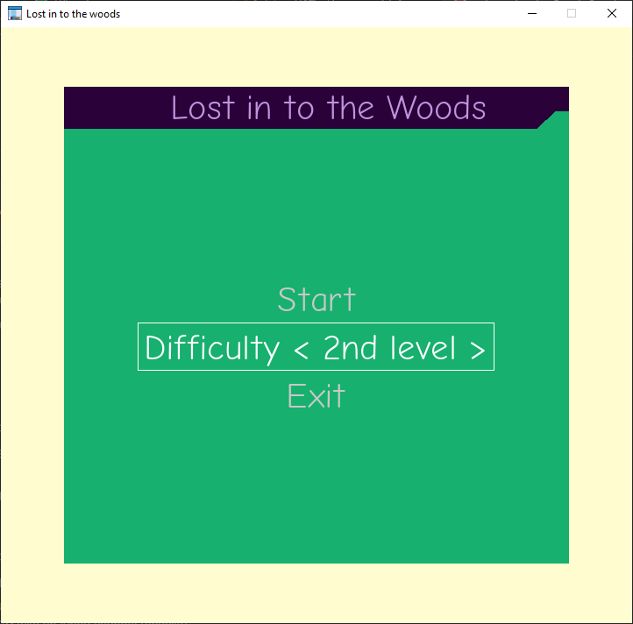

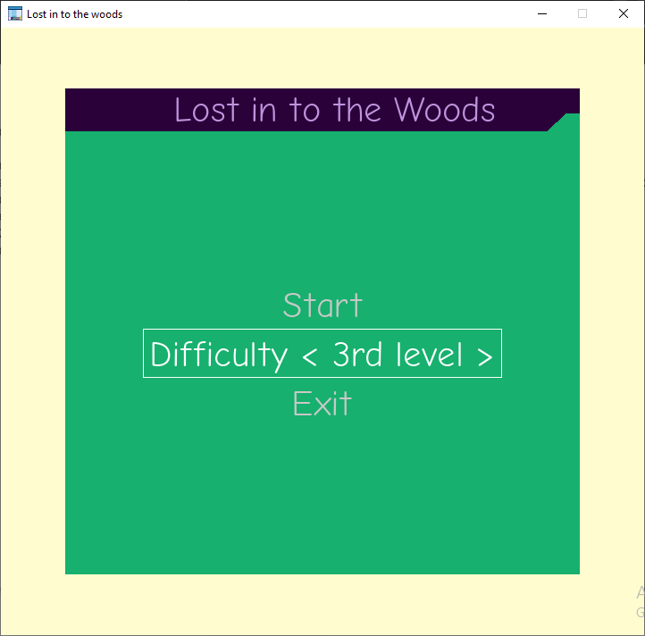

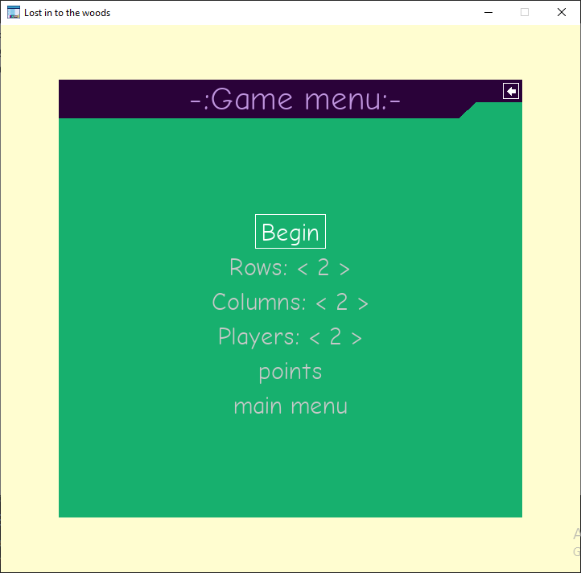

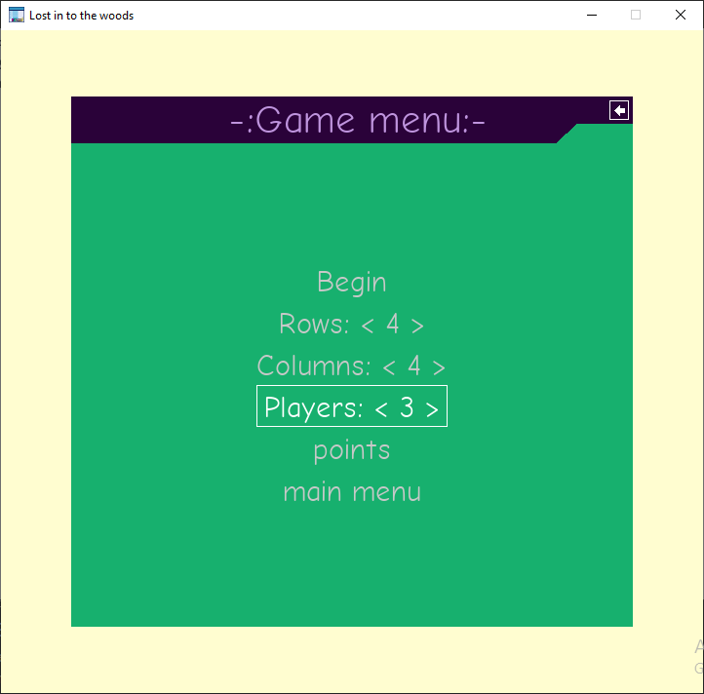

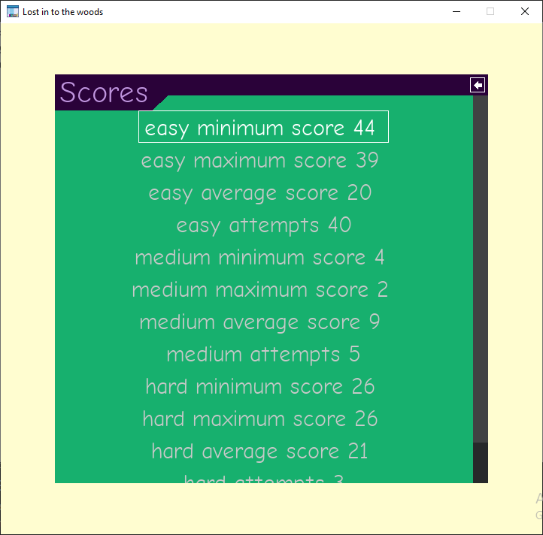

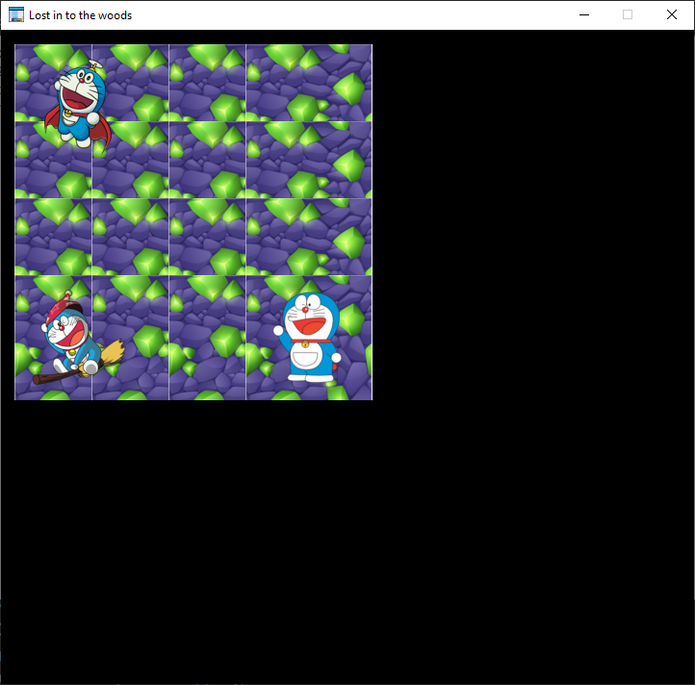

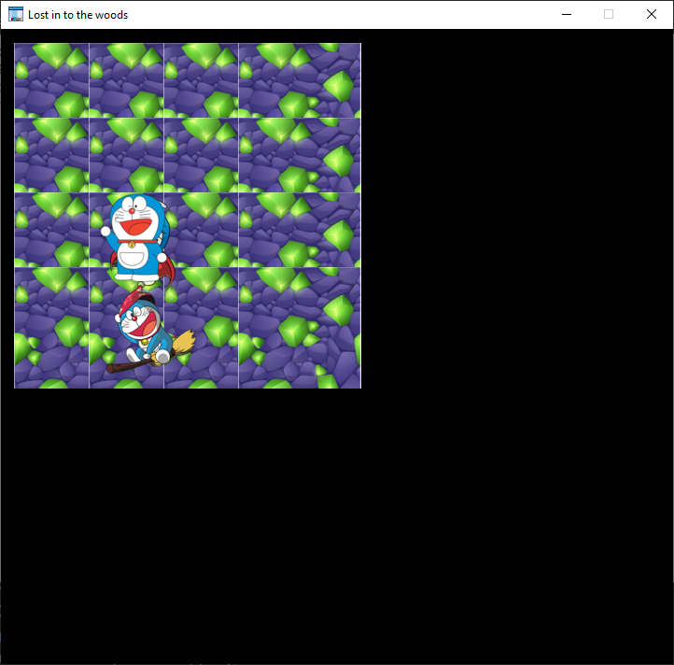

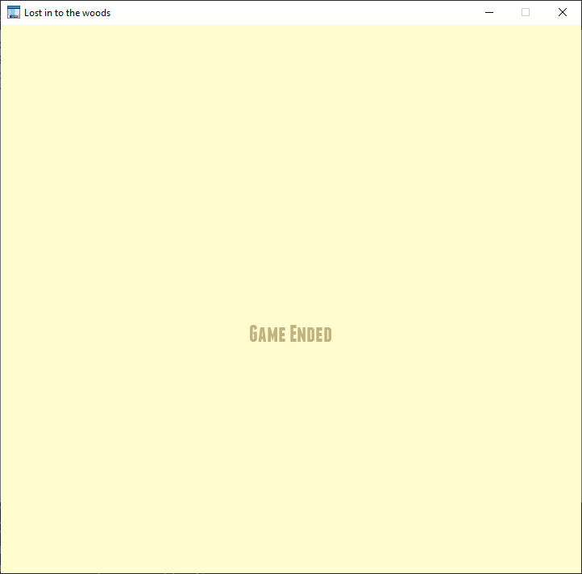

# Conclusion

To conclude this we can say that synergy between perceptive businessmen, developers, and the invaluable feedback from users is the cornerstone of successful product development. The ability of astute entrepreneurs to intuitively comprehend user needs creates a bridge, facilitating seamless communication. This, in turn, fosters a symbiotic relationship, where developers translate these insights into tangible, user-centric improvements. The collaborative bond formed between users and developers not only ensures the product aligns with user requirements but also provides a canvas for developers to showcase their creative expertise. As this intricate interplay continues, the product evolves, elevating user satisfaction and serving as a testament to the power of understanding, innovation, and cooperation in the world of business and technology.

# Reference:

Sodikin, S., Efendi, Y., & Yatimollah, Y. (2023). Implementation of the Multimedia Development Life Cycle in Making Educational Games About Indonesia. *CESS (Journal of Computer Engineering, System and Science)*, *8*(2), 595-606. <https://jurnal.unimed.ac.id/2012/index.php/cess/article/view/48870>

Antony, S., Sabari, T., Joshua, R. I., & Jayapandian, N. (2023, August). Artificial Intelligence Involvement in Graphic Game Development. In *2023 Second International Conference on Augmented Intelligence and Sustainable Systems (ICAISS)* (pp. 82-86). IEEE.